**National University of Computer and Emerging Sciences**



Lab Manual # 7

Programming Fundamentals (Section BSE- 1A)

|  |  |
| --- | --- |
| Course Instructor | Ms. Anoosha Khan |
| Lab Instructor(s) | Ms. Samia Akhter  Mr. Wajahat Ali |
| Section | BSE-1A |
| Semester | Fall 2022 |

Department of Computer Science FAST-NU, Lahore, Pakistan

**Lab Manual**

**Objectives**

The objectives of this lab are to cover the following:

* Nested for loop

# Exercise 1:

Armstrong number: It is an integer such that the sum of cube of its digits is equal to the number itself. Write a program in C++ that ask the user to enter two integers and displays all the Armstrong numbers between the interval.

**For example:** 371 is Armstrong number

(3*3*3)+(7*7*7)+(1*1*1)=371.

# Exercise 2:

# Write a C program that swaps two numbers without using third variable. Hint (use DMAS for the task).

Output:

Input value for x & y:

Before swapping the value of x & y: 5 & 7

After swapping the value of x & y: 7 & 5

# Exercise 3:

# Write a program in C++ that prints first 10 entries of multiplication tables from 1 to 5

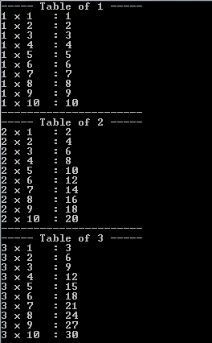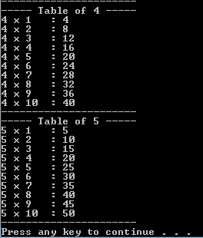

# Exercise 4:

Write a program in C++ that print Pascal’s triangle.

. 1

1 1

1 2 1

1 3 3 1

1 4 6 4 1

1 5 10 10 5 1

# Exercise 5:

Write a program to compute sinx for given x. The user should supply x and a positive integer n. We compute the sine of x using the series and the computation should use all terms in the series up through the term involving xn

sin x = x - x3/3! + x5/5! - x7/7! + x9/9!........xn/n!

# Exercise 6:

Using nested for loops, take input from the user and print the multiplication table:

Example:

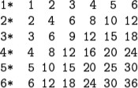Input: **6** Output:

# Exercise 7:

# Write a C++ program to display all prime from 1 to N.

**Input:**

Enter Value of N

N = 25

**Output:**

2, 3, 5, 7, 11, 13, 17, 19, 23